Cyber Security and Forensics

Practical 9: FTK Imager

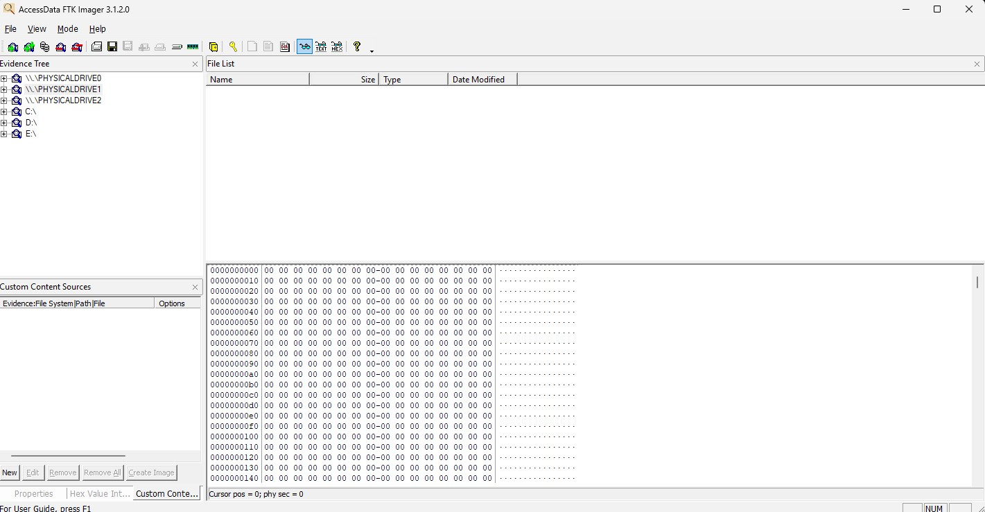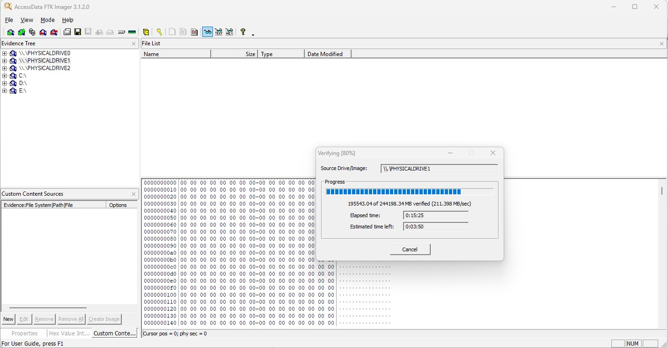

Aditya Anilkumar Lakhiwal – F004

MSc Cs - 40772240004

